# Exercises: Mine Monero

In this exercise you will learn how to mine **Monero** with “**XMRig**” miner. Monero is a **Proof of Work** cryptocurrency that can be mine with computational power from a **CPU** or **GPU**. This time we will mine it with CPU. There are currently no ASICs for Monero, which means that anyone with a computer can mine it.

First you will need “**XMRig**” miner.

## Download “XMRig” Miner

1. Go to “XMRig” website: <https://github.com/xmrig/xmrig#download> and go to releases.

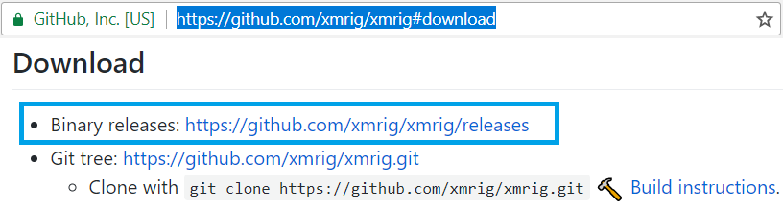

1. **Download** the desired version of the miner. Then install it.

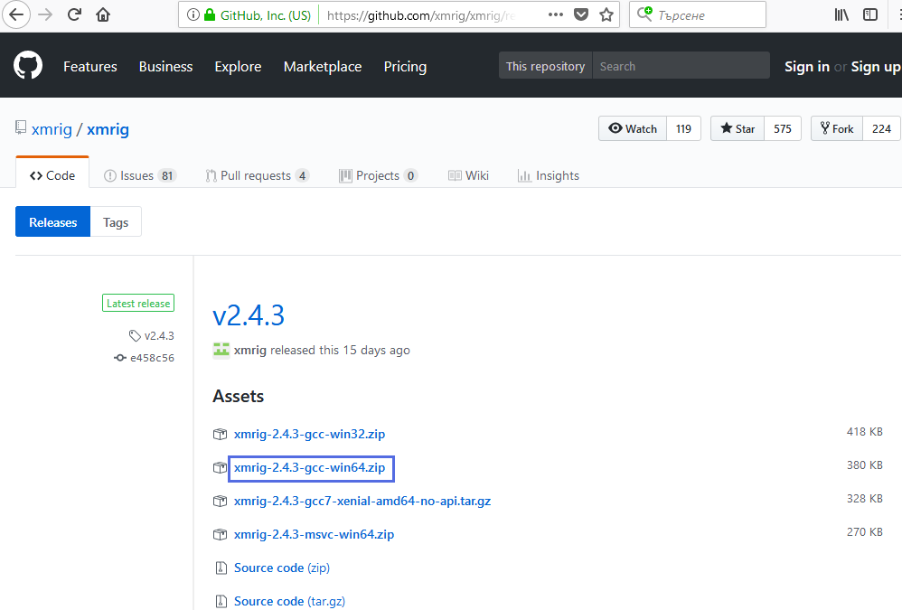

1. Right click and **unzip** the file.

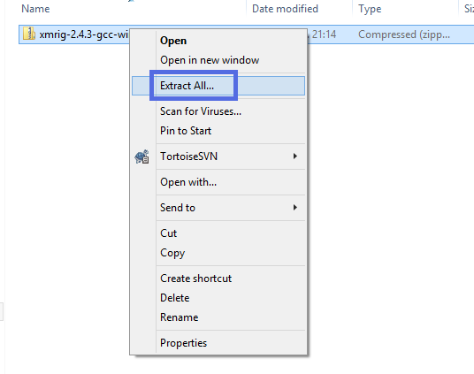

## Setup the Miner

1. Let`s **setup** **the “XMRig”.** Open the file **“start.cmd”** with your preferred text editor. In this exercise we will mine Monero in “**Hashvault**” pool. In the “start.cmd” after the “xmrig.exe” command we have some options.
   * Command **“-o”** is followed by “**URL of the mining server”** in our case this is “**pool.monero.hashvault.pro:5555**”.
   * Command **“-u”** wants “**username for mining server**”. In our example this is the **address of the** **Monero wallet** in which the pool will transfer payments.
   * Option **“-p”** is for password for mining server, we just leave it with value **“x”.**
   * With **“-k”** we send “keepalived” message for **prevent timeout** (need pool support).

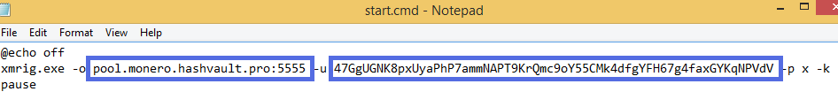

1. **Save** the “**start.cmd**” by pressing **“Ctrl + s”** end exit the text editor.

## Mine Monero Coins

1. Start **“XMRig”** by double click the file **“start.cmd”**.

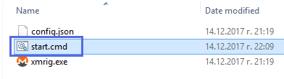

1. The **miner** will start and give as information about **connected pool** – “pool.monero.hashvault.pro:5555” and model and characteristics of **CPU**.

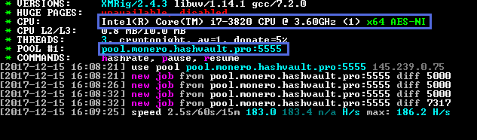

1. After connected to “Hashvault” the miner starts receiving “new jobs” from the pool. A short time after we have the first **accepted** share.

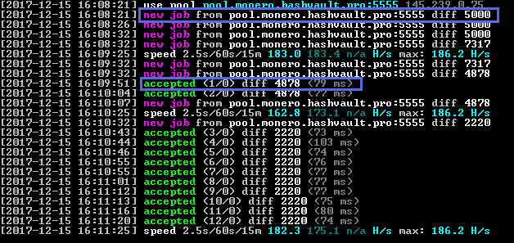

1. Also, you can see the information about **speed** and max speed. In runtime you can press **“h”** key to see the speed statistics anytime.

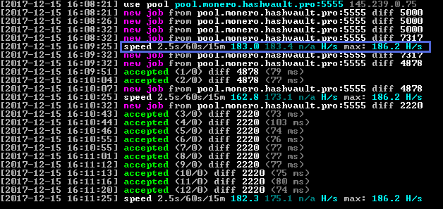

1. In runtime you can also press **“p”** to **pause** the miner and **“r”** to **resume** it. 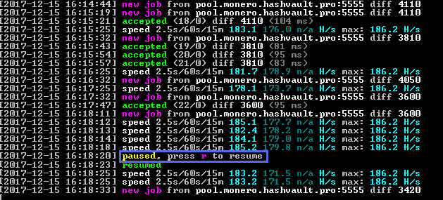

## Let`s See the Pool Statistics.

1. Go to <https://www.hashvault.pro/> and choose “Monero”.

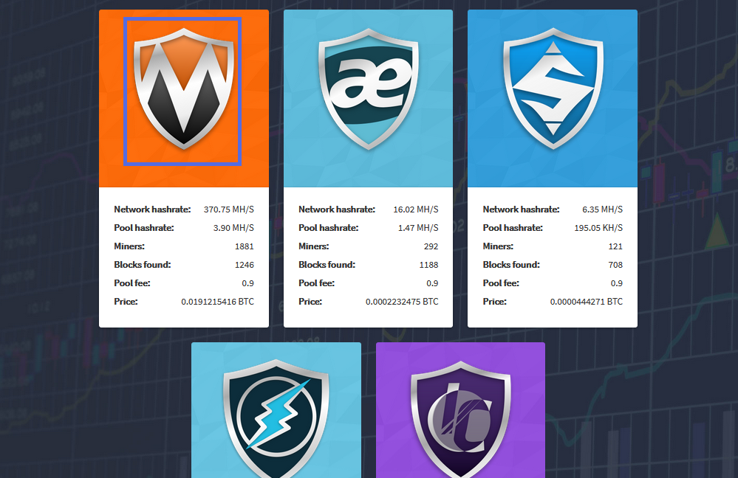

1. Click on the menu button.

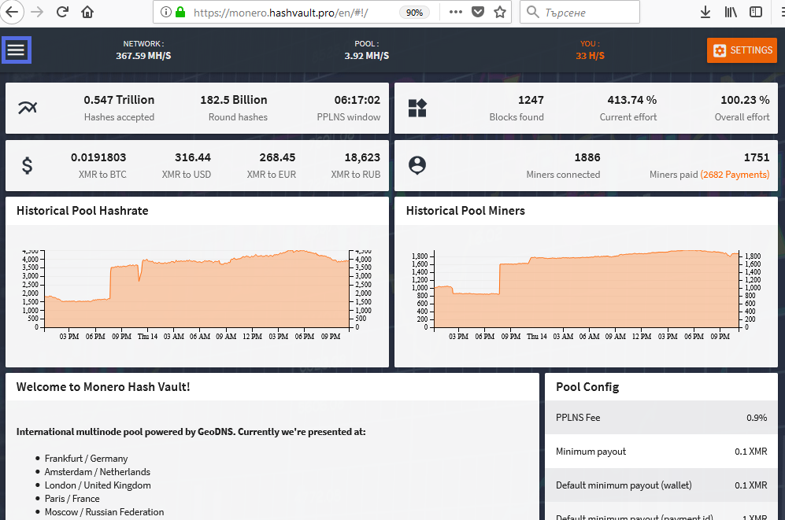

1. Click on “**Dashboard**”.

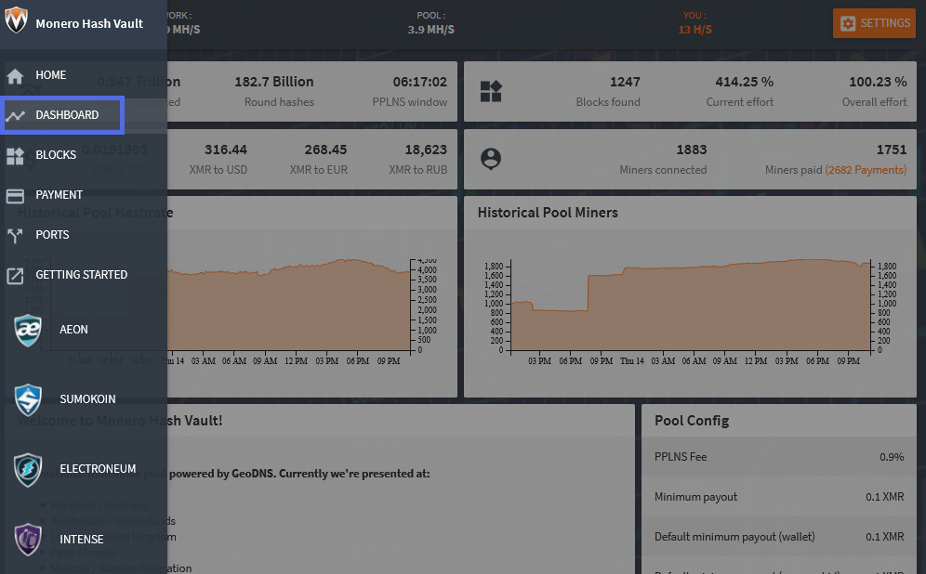

1. Enter your **payment address**.

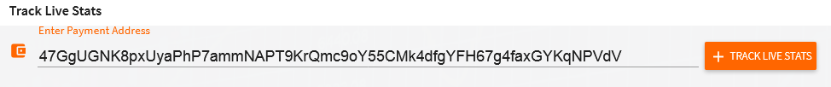

1. Here are the **pool** **statistics**. You can see the total **Hash Rate**, your miner’s statistics and other useful info.

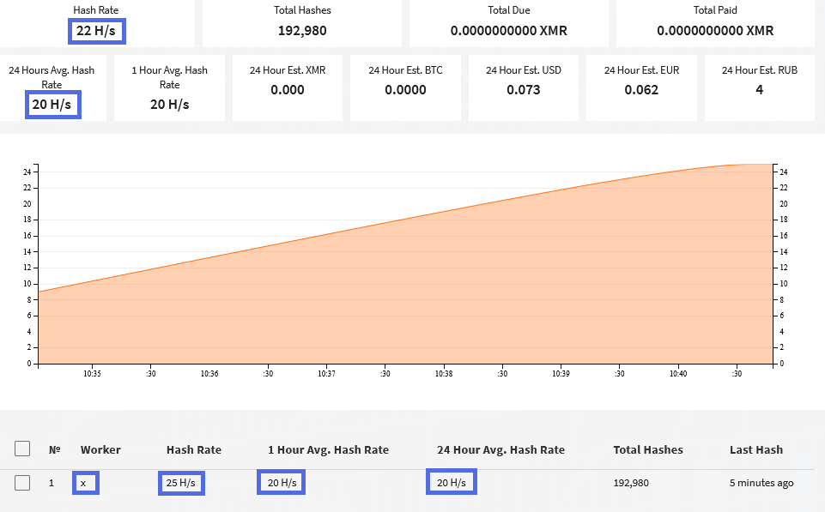

## Experiment with the Miner.

1. What is your **hash rate**?
2. How many XMR (**Monero**) you can mine for 24 hours?
3. In **“start.cmd”** try to add command **“--l log.txt”**. It will create log file of your mining. Open it and look at the file.

# What to Submit?

Create a **zip file** (e.g. your-name-monero-mining-exercise.zip) holding the screenshots of your mining and the log file.

Submit your zip file as **homework** at the course Web site.